大学英语六级口语考试试题构成
部 分 | 时 间 | 题 型 | 说 明
第一部分（Part1） | 3分钟 | 问答 | 考生自我介绍、回答问题。
第二部分（Part2） | 10分钟 | 发言和讨论 | 考生准备1分钟后，根据所给提示作个人发言（1.5分钟）；两位考生就指定的话题讨论（4.5分钟）。
第三部分（Part3） | 2分钟 | 问答 | 由考官进一步提问。

大学英语六级口语考试样题
CET Spoken English Test – Band Six
Sample Paper

Topic Area: Social Issues
Topic: Food Safety
Part 1 (3 minutes)
Examiner:
Topic A - 12
Hello, welcome to the CET Spoken English Test. We wish you both good luck today. Now let’s begin with self-introductions.
Candidate A, would you please start? [20 seconds]
Thank you. Candidate B, now it’s your turn. [20 seconds]

Thank you. OK, now that we know each other, let’s go on. First, I’d like to ask each of you a question.
Now Candidate A: Where do you usually have your meals? How do you like the food there?
Now Candidate A: Which dishes do you prefer, meat or vegetables? Why?
Now Candidate A: Do you find the food in your canteen expensive? Why do you say so?
Now Candidate A: What snacks and drinks do you usually have? Why?
Now Candidate A: Which do you prefer, Chinese dishes or Western dishes? Why?
Now Candidate B: Where do you usually have your meals? How do you like the food there?
Now Candidate B: Which dishes do you prefer, meat or vegetables? Why?
Now Candidate B: Do you find the food in your canteen expensive? Why do you say so?
Now Candidate B: What snacks and drinks do you usually have? Why?
Now Candidate B: Which do you prefer, Chinese dishes or Western dishes? Why?
Part 2 (10 minutes)
Examiner:
Now let’s move on to something more specific. The topic for our discussion today is “Food Safety”. Each of you will see a card with instructions for your presentation. You’ll have one minute to prepare, and each of you will have one and a half minutes to give your presentation. Now look at your card.
[1 minute later]
Now Candidate A, please begin.
[1.5 minutes later] Candidate B, now it’s your turn.
Card A
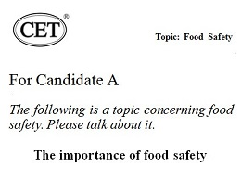
Card B
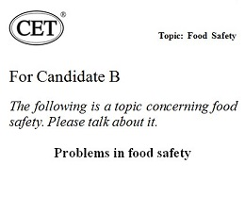
Right. Now that we’ve talked briefly about food safety, I’d like you to develop this topic further and have a discussion for about four and a half minutes. During the discussion you may argue and ask each other questions. Our discussion is about
how to ensure food safety.
Remember, this is a pair activity and you need to interact with each other. So don’t keep talking without giving the other a chance. Now let’s begin.
[4.5 minutes later]
All right, that’s the end of the discussion.
Part 3 (5 minutes)
Examiner:
Now I’d like to ask you just one last question on the topic of “Food Safety”.
Why are people more concerned about food safety these days?
Why do some young people like junk food?
What do you think of some people going on a diet?
Why do some people choose to eat vegetarian food only?
OK, that’s the end of the test. Thank you.
体例说明：
内容 | 体例 | 举例
• 主考用语 : | 黑体 | Hello.
• 时间提示 : | [ 白体 ] | [1 minute]
• 过程说明 : | [ 斜体 ] | [ Part 1 ]

