(省)英语
准考证号____________________ 姓名________________
（在此卷上答题无效）
机密★2013年6月19日
江西省2013年中等学校招生考试
英语试题卷
说明：1.本卷分为试题卷和答题卷，答案请涂写在答题卷上，不要在试题卷上作答，否则不给分。
2.本卷共有5大题、91小题，全卷满分120分，考试时间为120分钟。

一、听力测试（25分）
现在是试听时间。请听一段对话，然后回答问题。
What is the boy going to buy?
A. Some juice. B. Some oranges. C. Some apples.
答案是C。
A)请听下面5段对话。每段对话后有一小题，从题中所给的A、B、C三个选项中选出最佳选项，并在答题卷上将该项涂黑。听完每段对话后，你都将有10秒钟的时间回答有关小题和阅读下一小题。每段对话读两遍。（每小题1分）
1. What does Mike want to buy?
A. A raincoat. B. A T-shirt. C. A sweater.
2. How often does the bus run?
A. Every ten minutes B. Every twenty minutes. C. Every thirty minutes.
3. How's the weather tomorrow?
A. Sunny. B. Rainy. C. Windy.
4. Whom did Jenny spend her holidays with?
A. She threw away the old shoes.
B. The old shoes are under the chair.
C. She has never seen the old shoes.
B)请听下面3段对话和2段独白。每段对话或独白后有几个小题，从题中所给的A、B、C三个选项中选出最佳选项，并在答题卷上将该项涂黑。听每段对话或独白前你都将有30秒钟的时间阅读各小题。每段对话或独白读两遍。（每小题1分）
请听第1段对话，回答第6至第7小题。
6. Where is Peter learning to drive?
A. At AA Driving School.
B. At ABC Driving School.
C. At ABB Driving School.
7. How many lessons has Peter had?
A. 10. B. 140. C. 14.
请听第2段对话，回答第8至第10小题。
8. Where will the two speakers go for the picnic?
A. By the lake. B. In the mountain C. In the park.
9. How will the two speakers go there?
A. By bike. B. By car. C. By bus.
10. Who will go with the two speakers?
A. Linda. B. Betty. C. Jim.
请听第3段对话，回答第11至第13小题。
11. When is Fred going to the United States?
A. Next Monday. B. Next Tuesday. C. Next Wednesday.
12. How will Fred and Lily communicate with each other?
A. By writing letters. B. By making phone calls. C. By chatting online.
13. What can we know about Fred?
A. Fred and Lily win study together in the United States.
B. Fred will study in the United States for a long time.
C. Fred's parents want him to work in the United States.
请听第1段独白，回答第14至第16小题。
14. Who is Tommie?
A. Bob's cousin, B. Bob's brother. C. Bob's friend.
15. What was Tommie like two years ago?
A. He was outgoing.
B. He was taller than Bob.
C. He had a child's voice.
16. Which of the following is true?
A. Tommie is still shy.
B. Tommie studies hard.
C. Tommie studies at Beijing University.
请听第2段独白，回答第17至第20小题。
17. What time does Cindy get up?
A. At 6:30. B. At 7:00. C. At 7:30.
18. What kind of drink does Cindy have in the morning?
A. Tea. B. Coffee. C. Milk.
19. Where does Cindy work?
A. At a store. B. In a hospital. C. At a bank.
20. What can we get from the passage?
A. Cindy works far away from her home.
B. Cindy stays up late at night.
C. Cindy takes a train to work.
C）请听下面一段短文，根据短文内容完成表格，每个空格不超过3个单词。将答案填写到答题卷的相应位置。听短文前你将有50秒钟的时间阅读表格内容。短文读两遍。（每小题1分）
21. There’s a talk for the International ___________ in our city.
22. Miss Black teaches at the university ___________.
23. She’s giving a talk at ___________ on Saturday evening in the library.
24. She ___________ through three different countries.
25. She met a famous ____________ in Africa.
二、单项填空(15分)
请阅读下面各小题，从题中所给的A、B、C、D四个选项中选出可以填入空白处的最佳选项，并在答题卷上将该项涂黑。(每小题1分)
26. There are lots of restaurants in our town. And most of _____ are clean and cheap.
A. it B. they C. us D. them
27. She always does very well in the English exams. But she can _____ understand English radio programs.
A. always B. hardly C. already D. easily
28. Lee is new in Nanchang. Maybe he needs a _____for sightseeing.
A. watch B. ticket C. map D. notebook
29. I want to relax myself fight now. Would you please change to _____ music?
A. sad B. loud C. exciting D. gentle
30. There's only one day to go. You _____ finish your schoolwork by tomorrow.
A. can B. will C. must D. may
31. — I think students should have mobile phones to call their parents.
—_____. They often use them to play games instead.
A. I hope so B. I don't agree
C. No problem D. Good idea
32. Do you know _____I saw yesterday? It was my favorite star, Jackie!
A. whom B. when C. where D. how
33. — Have you had your breakfast yet?
—Yes. Mom _____ it for me.
A. was cooking B. is cooking C. will cook D. cooked
34. Anna is going on a tour of Xi’an, and she wants to _____Chinese history.
A. dream of B. learn about C. look through D. pass on
35. The Chinese writer has got lots of fans in France. His new book _____ into French as soon as it came out.
A. was translated B. translated
C. is translated D. translates
36. Kate's dad is getting old. She will go back home to see him _____it is convenient.
A. because B. whenever C. although D. unless
37. Ted was hard-working. His success made him work_____.
A. harder B. hardest
C. more quickly D. most quickly
38. Lucy is shy. She would not invite her classmates _____dancing with her.
A. practice B. practices C. practicing D. to practice
39. Tom wants to be a singer and he_____ singing lessons to do it.
A. took B. has taken C. is taking D. was taking.
40. —I’m very sorry, Allen. I can't find your favorite CD.
— _____, Torn. I'll go and buy another one.
A. It doesn't matter B. Don't say that
C. Sure D. You are kidding.
三、完形填空(25分)
A) 请先阅读下面短文，掌握其大意，然后从各小题所给的A、B、C、D四个选项中选出可以填入相应空白处的最佳选项，并在答题卷上将该项涂黑。(每小题1分)
I was so excited after I had found the holiday in the guidebook. It said, “Enjoy a week of sightseeing in one of Europe’s most beautiful cities 41 staying at one of its best hotels. ” Now I wasn’t so sure. I had waited fifteen minutes at reception (前台) when I 42 and now the shower in my room wasn’t working. I 43 hotel reception.
“Hello. This is Room 308. There isn’t any 44 in my bathroom. ”
“Are you sure?”
“Of course I’m sure!”
“I’ll 45 our hotel engineer at once. ”
An hour later, the engineer came to look at the 46 . He hit the pipes (水管) a few times and looked 47 . “Sorry, but I cannot fix it today. Maybe, tomorrow.” Then he 48 his hand. I couldn’t believe it! He wanted a tip (小费) for doing 49 ! I was very angry. But suddenly, I had a better idea. 50 , I gave the engineer a few coins. He hadn’t fixed my shower but he had taught me something 51 staying in his country. Two minutes later I was at the reception desk. I explained the 52 to the receptionist (接待员) and he replied, “Sorry. This is a 53 situation, but what can we do?” I knew exactly 54 to do. I gave the hotel manager a very large tip. Fifteen minutes later I 55 into Room 405. It was twice the size of Room 308, it had a wonderful view (景色) of the city, a comfortable bed and, most importantly, there was water in the bathroom.
41. A. since B. while C. after D. before
42. A. arrived B. passed C. left D. stopped
43. A. asked B. ordered C. called D. told
44. A. toothpaste B. water C. shampoo D. soap
45. A. send B. catch C. trouble D. watch
46. A. door B. TV C. shower D. fridge
47. A. proud B. worried C. angry D. excited
48. A. put up B. cleaned up C. looked after D. held out
49. A. nothing B. anything C. something D. everything
50. A. Seriously B. Especially C. Quickly D. Luckily
51. A. at B. with C. of D. about
52. A. problem B. idea C. way D. mistake
53. A. helpful B. perfect C. terrible D. busy
54. A. how B. what C. why D. where
55. A. broke B. looked C. rushed D. moved
B) 请先阅读下面短文，掌握其大意，然后从方框中所给的词中选出最恰当的10个，用其适当形式填空，并将答案填写到答题卷的相应位置。每个词限用一次。(每小题1分)
take tree beach like island but
leave exciting enjoy outside as something

My favorite TV program is a reality show called Survivor (幸存者). It isn’t on TV at the moment 56 it was on last year.
In the show, two teams of people are taken to a (an) 57 . All of them have to sleep 58 because there aren’t any houses or hotels. They usually choose 59 really useful like a toothbrush since they can only 60 one thing with them. The people also have to find food and they spend a lot of time fishing and collecting fruit from the 61 . Every week one person has to 62 . At the end, there are only two people on the island and one them is chose 63 the winter.
I really like Survivor because it’s very 64 and the people have to do things like hunting for food. I really 65 myself when I watch it. I don’t want to be on the show, however, I like living in a house!
四、阅读理解(40分)
A)请阅读下面短文，根据短文内容从每小题所给的A、B、C、D四个选项中选出最佳选项，并在答题卷上将该项涂黑。（每小题2分）
A

Mary
The Musical (音乐剧)

Don't miss Mary The Musical at Cambridge Theater London!

Performances start every evening at 7 from this Saturday.

Tickets are 20 pounds for adults and 15 pounds for children and can be bought online or from the theater.
Teenage
Drawing
Competition

10-16 year olds are welcome to take part in an exciting drawing competition on Saturday 6th August at 2 pm at Westfield Shopping Center.

It is free to enter and the first prize is a trip to New York!

Meet Adele

Come and meet the famous singer Adele at St. James's Park this Sunday, April 25.Adele will be singing songs from her latest CD. The event starts at noon and ends at 4 Pm.

Tickets are 8 pounds and can be bought at St. James's Park.

66. How much are the musical tickets for two children?
A. 16 pounds, B, 35 pounds. C. 30 pounds. D. 40 pounds.
67.When will the Teenage Drawing Competition be held?
A. On June 7th. B. On August 6th.
C. On September 20th. D. On April 25th.
68. Where can you watch Adele's performance this Sunday afternoon?
A. At St. James' s Park. B. At Westfield Theater.
C. At Westfield Shopping Center. D. At Cambridge Theater.

B
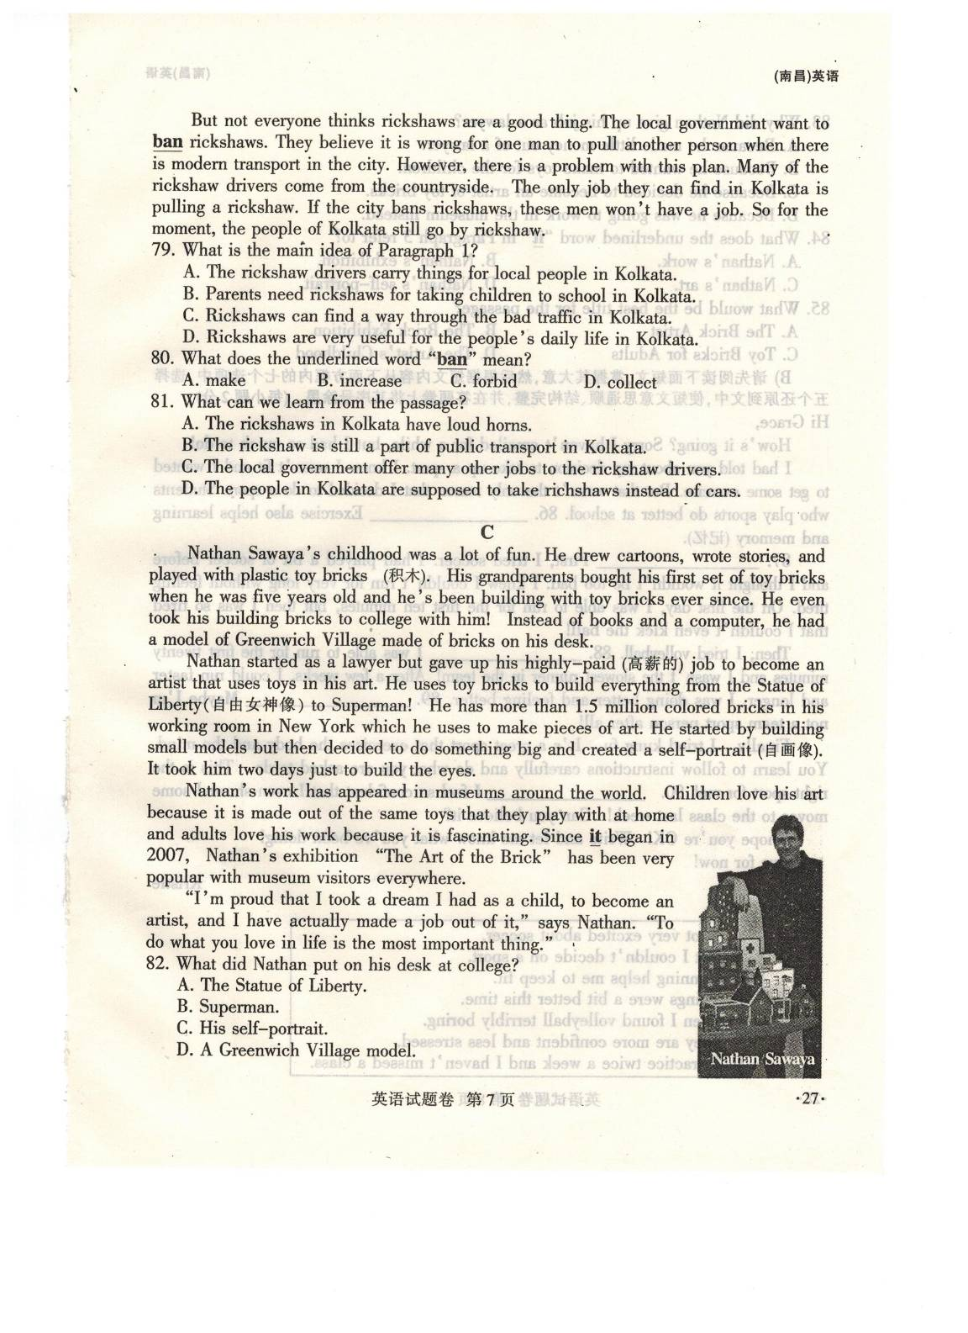
Nathan Sawaya's childhood was a lot of fun. He drew cartoons, wrote stories, and played with plastic toy bricks (积木). His grandparents bought his first set of toy bricks when he was five years old and he's been building with toy bricks ever since. He even took his building bricks to college with him! Instead of books and a computer, he had a model of Greenwich Village made of bricks on his desk.
Nathan started as a lawyer but gave up His highly-paid (高薪的) job to become an artist that uses toys in his art. He uses toy bricks to build everything from the Statue of Liberty(自由女神像) to Superman! He has more than 1.5 million colored bricks in his working room in New York which he uses to make pieces of art. He started by building small models but then decided to do something big and created a self-portrait (自画像). It took him two days just to build the eyes.
Nathan's work has appeared in museums around the world. Children love his art because it is made out of the same toys that they play with at home and adults love his work because it is fascinating. Since it began in2007, Nathan's exhibition "The Art of the Brick" has been very popular with museum visitors everywhere.
"I'm proud that I took a dream I had as a child, to become an artist, and I have actually made a job out of it," says Nathan. "To do what you love in life is the most important thing."
69. What did Nathan put on his desk at college?
A. The Statue of Liberty. B. Superman.
C. His serf-portrait. D. A Greenwich Village modal.
70. Why did Nathan give up his job as a lawyer?
A. Because he made little money out of a lawyer.
B. Because he wanted to make toys for the children.
C. Because he decided to become an artist of toy bricks.
D. Because he was going to work in the museum instead.
71. What does the underlined word "it" in Paragraph 3 refer to?
A. Nathan's work. B. Nathan's exhibition.
C. Nathan's art. D. Nathan's self-portrait
72. What would be the best title for the passage?
A. The Brick Artist B. The Brick Exhibition
C. Toy Bricks for Adults D. The Artist's Childhood
C
Should we be afraid of sharks? Maybe not. New research into the reasons for shark attacks (攻击) suggests that sharks don’t like the way humans taste! In fact, most people who are attacked by the shark are still alive after receiving only one bite (咬). Why is this?
There are many opinions to explain why sharks sometimes attack people. One opinion is that sharks are just curious (好奇的). We know that sharks are the strongest animals in their environment, so they are not afraid of anything. Naturally, that means they are curious when they meet something unusual. Because they don’t have hands or feet., the only way they can find out an object is to bite it! It is thought that sharks sometimes bite humans for this reason, and then swim away.
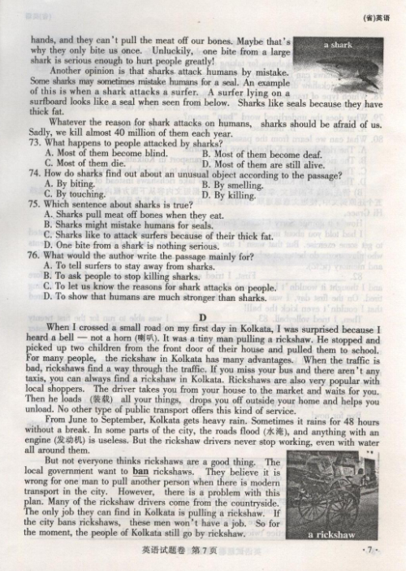
Scientists also say that sharks would not waste energy trying to eat a human, as we have a lot of bones (骨头). It is hard for a shark to eat us because sharks don’t have hands, and they can’t pull the meat off our bones. Maybe that’s why they only bite us once. Unluckily, one bite from a large shark is serious enough to hurt people greatly!
Another opinion is that sharks attack humans by mistake. Some sharks may sometimes mistake humans for a seal. An example of this is when a shark attack attacks a surfer. A surfer lying on a surfboard looks like a seal when seen from below. Sharks like seals because they have thick fat.
Whatever the reason for shark attacks on humans, sharks should be afraid of us. Sadly, we kill almost 40 million of them each year.
73. What happens to people attacked by sharks?
A. Most of them because blind. B. Most of them because of deaf.
C. Most of them died. D. Most of them are still alive.
74. How do sharks find out about an unusual object according to the passage?
A. By biting. B. By smelling.
C. By touching. D. By killing.
75. Which sentence about sharks is true?
A. Sharks pull meat off bones when they eat.
B. Sharks might mistake humans for seals.
C. Sharks like to attack surfers because of their thick fat.
D. One bite from a shark is nothing serious.
76. What would the author write the passage mainly for?
A. To tell surfers to stay away from sharks.
B. To ask people to stop killing sharks.
C. To let us know the reasons for shark attacks on people.
D. To show that humans are much stronger than sharks.
D
When I crossed a small road on my first day in Kolkata, I was surprised because I heard a bell-not a horn (喇叭), It was a tiny man pulling a rickshaw, He stopped and picked up two children from the front door of their house and pulled them to school. For many people, the rickshaw in Kolkata has many advantages. When the traffic is bad, rickshaws find a way through the traffic. If your miss your bus and there aren't any taxis, you can always find a rickshaw in Kolkata. Rickshaws are from your house to the market and waits for you. Then he loads (装载)all your things, drops you off outside your home and helps you unload, No other type of public transport offers this kind of service.
From June to September, Kolkata gets heavy rain. Sometimes it rains for 48 hours without a break. In some parts of the city, the roads flood (水淹), and anything with an engine(发动机) is useless, But the rickshaw drivers never stop working, even with water all around them.
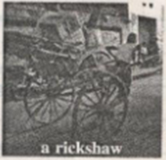
But not everyone thinks rickshaws are a good thing. The local government want to ban rickshaws. They believe it is wrong for one man to pull another person when there is modern transport in the city. However, there is a problem with this plan. Many of the rickshaw drivers come from the countryside. The only job they can find in Kolkata is pulling a rickshaw, If the city bans rickshaws, these men won't have a job. So for the moment, the people of Kolkata still go by rickshaw.
77. What is the main idea of Paragraph 1?
A. The rickshaw drivers carry things for local people in Kolkata.
B. Parents need rickshaws for taking children to school in Kolkata.
C. Rickshaws can find a way through the bad traffic in Kolkata.
D. Rickshaws are very useful for the people's daily life in Kolkata.
78. Which type of transport may you take when the roads flood in Kolkata?
A. A bus. B. A taxi. C. A car. D. A rickshaw.
79. What does the underlined word "ban" mean?
A. make B. increase C. forbid D. collect
80. What can we learn from the passage?
A. The rickshaws in Kolkata have loud horns.
B. The rickshaw is still a part of public transport in Kolkata.
C. The local government offer many other jobs to the rickshaw driven.
D. The people in Kolkata are supposed to take rickshaws instead of cars.
B)请先阅读下面短文，掌握其大意，然后根据短文内容从下面方框内的七个选项中，选择五个还原到文中，使短文意思通顺、结构完整，并在答题卷上将其序号涂黑。(每小题2分)
Hi Grace,
How's it going? Sorry I haven't emailed for a while, but I had so much to do!
I had told you about my decision to take up a sport. I knew I wasn't fit and I wanted to get some exercise. But that wasn't the only reason that I decided to do a sport. Students who play sports do better at school. 81. Exercise also helps learning and memory (记忆).
82. First, I tried soccer. I had played a bit of soccer before and I thought it wouldn't be too bad. I knew I couldn't nm for very long without feeling tired. On the first day, I was able to nm for the first ten minutes, but then I was so tired that I couldn't even kick the ball!
Then, I tried volleyball. 83. I was able to nm for the first twenty minutes and I wasn't the slowest runner in the team! After a few weeks .I could run faster and longer. I was doing better and feeling better. 84. Maybe I'm not a team sport person after all!
Finally, I tried kung fu (功夫). It's a great sport that exercises the body and the mind. You learn to follow instructions carefully and do what you are asked to do. This is the fight sport for me! 90. I feel so confident that l even showed some moves to the class last week! Can you believe it?
I hope you're OK! Write and let me know what you've been doing!
Bye for now!
Kristie

A. I got very excited about soccer.
B. But I couldn't decide on a sport.
C. Running helps me to keep fit.
D. Things were a bit better this time.
E. Then I found volleyball terribly boring.
F. They are more confident and less stressed.
G. I practice twice a week and I haven't missed a class.

五、书面表达(15分)
母爱情深，母爱无价；学会感恩，学会回报。某英语网站举办以“My mother”为题的英语征文活动。请你根据下列思维导图提供的信息，写一篇短文，介绍自己的母亲和你们的真情故事。
提示：1.短文应包括导图中的全部信息，条理清楚，行文连贯，段落分明;
2.短文中不能出现真实的人名和地名。
3.词数不少于80，开头已给出:不计人总词数。
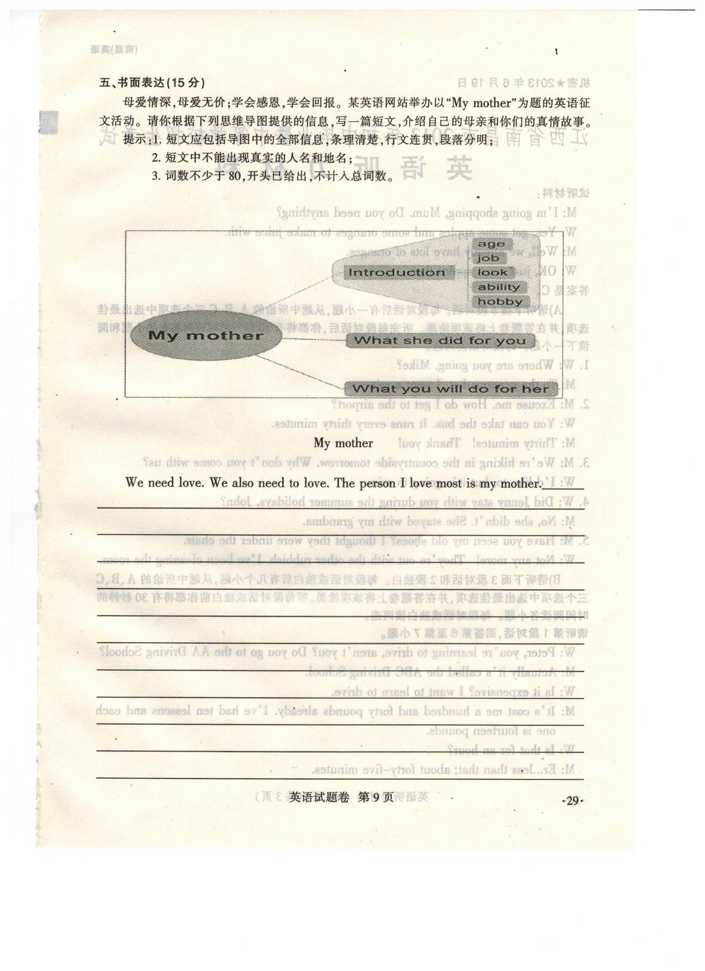
My mother
We need love. We also need to love. The person I love most is my mother._______________
______________________________________________________________________________
______________________________________________________________________________
______________________________________________________________________________
______________________________________________________________________________
______________________________________________________________________________
______________________________________________________________________________

机密★2013年6月19日
江西省2013年中等学校招生考试
英 语 听 力 材 料

试听材料：
M: I’m going shopping, Mum. Do you need anything?
W: Yes, get some apples and some oranges to make juice with.
M: Well, we already have lots of oranges.
W: OK, just some apples then.
答案是C。
A）请听下面5段对话。每段对话后有一小题，从题中所给的A、B、C三个选项中选出最佳选项，并在答题卷上将该项涂黑。听完每段对话后，你都将有10秒钟的时间回答有关小题和阅读下一小题。 每段对话读两遍。
1. W: Where are you going, Mike?
M: TO the supermarket. I want a raincoat.
2. M: Excuse me. How do I get to the airport?
W: You can take the bus. It runs every thirty minutes.
M: Thirty minutes! Thank you!
3. M: We’re hiking in the countryside tomorrow. Why don’t you come with us?
W: I’d like to, but it’s going to rain.
4. W: Did Jenny stay with you during the summer holidays, John?
M: No, she didn’t. She stayed with my grandma.
5. M: Have you seen my old shoes? I thought they were under the chair.
W: Not any more! They’re out with the other rubbish. I’ve been cleaning the room.
B)请下面3段对话和2段独白。每段对话或独白后有几个小题，从题中所给的A、B、C三个选项中选出最佳选项，并在答题卷上将该项涂黑。听完每段对话或独白前，你都将有30秒钟的时间阅读各小题。 每段对话或独白读两遍。
请听第1段对话，回答第6至第7小题。
W: Peter, you’re learning to drive, aren’t you? Do you go to the AA Driving School?
M: Actually it’s called the ABC Driving School.
W: Is it expensive? I want to learn to drive.
M: It’s cost me a hundred and forty pounds already. I’ve had ten lessons and each one is fourteen pounds.
W: Is that for an hour?
M: Er … less than that, about forty-five minutes.
请听对2段对话，回答第8至第10小题。
W: We shall have a picnic this weekend. Can you come, Jacky?
M: Yes, I can. Where shall we have the picnic?
W: We shall have the picnic in the park.
M: How shall we go there?
W: We shall go there by bike.
M: My sister Betty will come with us. Will your brother Jim come, too?
W: No, he won’t come. He will go to a party.
M: Oh, that’s too bad.
W: It doesn’t matter. I think we’ll enjoy it.
M: That’s for sure.
请听第3段对话，回答第11至第13小题。
W: Hi, Fred. How are you?
M: Fine. I must say good-bye to you, Lily. I am going to the United States next Monday.
W: For how long?
M: I don’t know. My mum and dad want me to finish my college there.
W: Oh! I am so sorry. You are going away for such a long time.
M: Don’t worry. We can chat online.
W: Good idea.
M: Keep in touch, Lily. I’ll miss you.
W: Me, too. Take care!
请听第1段独白，回答第14至第16小题。
Hello, everyone. I’m Bob. I’d like to say something about my cousin Tommie. You won’t believe your eyes then you see Tommie! He has changed a lot. The last time I saw him was only two years ago when he was in Grade 8. He was much shorter than me at the time, and he still had a child’s voice. He was so shy when he saw me. He did not say much but he smiled a lot. Now Tommie is taller than me. He is in high school. He is not shy any more. He told me a lot of interesting things about his class when we met. He is working very hard at his lessons now, because he wants to go to Beijing University.
请听第2段独白，回答第17至第20小题。
I’m Cindy. My day begins far too early. I get up at 7:30 — usually after a late night. This means that I really need my coffee in the morning. I catch a bus to work. It’s not very far so I don’t get a chance to sleep in the way to the store where I work. That’s a pity because most mornings I really need more sleep. I work from eight to five with a lunch break in between. When I got home, I’m very tired. I keep saying I will go to bed early, but I can seldom do that.
C)请下面一篇短文，根据短文内容完成下列句子，每个空格不超过3个单词。将答案填写到答题卷相应位置。听短文前你将有50秒钟时间阅读句子内容。短文读两遍。
Attention, please. On Saturday evening, there’s a talk for the International Club in our city by a famous writer, Miss Black. She teaches at the university in England. Well, she’s giving a talk at 8 pm on Saturday evening in the library. I’m sure you’ll find it very interesting. Miss Black has just returned from Africa and will talk about all her experiences there. She traveled through three different countries. She met lots of interesting people, including a famous actor. I’m sure the evening will be very popular. Have a good time. Thank you!

机密★2013年6月19日
江西省2013年中等学校招生考试
英语试题参考答案及评分意见
一、听力侧试（共25小题，每小题1分）
1-5 ACBCA 6-10 BACAB 11-15 ACBAC 16-20 BCBAB
21. Club 22. in England 23. 8 pm
24. traveled/travelled 25. actor
(注： 21、22小题的答案，其首字母小写不扣分。)
二、单项填空 （共15题，每小题1分）
26-30 DBCDC 31-35 BADBA 36-40 BADCA
三、完形填空（共25小题，每小题1分）
A) 41-45 BACBA 46-50 CBDAC 51-55 DACBD
B) 56. but 57. island 58. outside 59. something 60. take
61. trees 62. leave 63. as 64. exciting 65. enjoy
(注：61小题的词形未变扣0.25分)
四、阅读理解（共20小题，每小题2分）
66-70 CBADC 71-75 BADAB
76-80 CADCB 81-85 FBDEG
五、书面表达（15分）
One Possible Version
My mother
We need love. We also need to love. The person I love most is my mother. The person I love most is my mother. My mother is 41 years old. She is of medium build with long black hair. Shi is quiet. She is a history teacher in a middle school. She likes dancing. She can cook delicious food.
She did a lot for me when I was a child. She bought whatever I needed for my study, even though she didn’t have much money. She sent me from piano lessons to dancing lessons at the weekend. She cooked delicious and healthy food for me.
When I grow up, I will do what I can to make my mother happy. I will find a good job after I graduate from college. I’ll save money and buy beautiful clothes that make her look still young. I’ll take her to wonderful sights around China. Most importantly, I will stay with her when I have free time. That’s what she wants most, I think.

评分意见：

（一）总体原则
考查学生综合运用语言知识的能力，注重语言表达的意义和流畅性。
（二）内容要点
1. Introduction
①age ②job ③look ④ability ⑤hobby
2. What she did for you
3. What you will do for her
(三) 评分档次
1. 第一档（13-15分）
信息完整，表达流畅，无语言错误或基本无语言错误。
2. 第二档（10-12分）
信息基本完整，表达较流畅，有少量错误，但不影响意思表达。
3. 第三档（7-9分）
能传达部分信息，表达不够流畅，但句子基本可读。
4. 第四档（4-6分）
只能传递少量信息，表达不通顺，只有少量句子可读。
5. 第五档（1-3分）
只能传递个别信息，表达不清楚，只有个别句子可读。
（四）建议
3个内容要点，每个要点各5分。第一个内容的要点的5点信息不必按所给次序表达，每点信息各1分。

